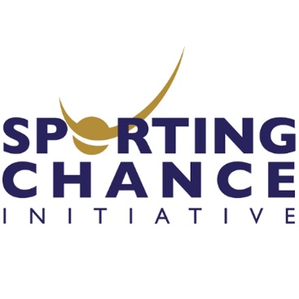
GUIDANCE DOCUMENT
Use the information provided here in red to help you complete the Application Form.

Sports Innovation Challenge: 2017/18 Entry Form
Personal Details
Name
University
Course
Type of student | ☐ Undergraduate ☐ Postgraduate ☐ Graduate (if a graduate, please indicate when you graduated)
Email
Contact Telephone Number
Have you ever engaged with any other Support Agencies (e.g. SIE, Scottish Enterprise, HIE, Converge Challenge etc.) | ☐Yes ☐No  If you selected yes, please specify:
Have you entered the Challenge before? | ☐Yes ☐No
Business Details
Business Name | - Even if you don’t have a formal business name, please provide a name for your idea
Is the Business trading? | ☐Yes ☐No
What is your role? | - Are you the Founder/CEO/Other?
Other team members?

Please answer each section and state the word count. There is no right or wrong answer, we are looking to test your knowledge, market awareness and passion.
Your Innovative Idea (max.100 words)
- Outline your business idea in a way that catches attention
- What makes your idea innovative?
- What problem have you solved or what opportunity have you identified?
- What is the want/need for your idea?

Word Count:

Your Business (max.400 words)
- What stage are you at (idea, proof-of-concept, prototype/service design or fully developed)?
- What is the business USP (Unique Selling Point)?
- Who are your competitors?
- What is your competitive advantage? e.g. what does your product or service have or do differently that will give you an advantage over your competitors?
- How will your business make money?
- What will you charge and why?

Word Count:
You (Max. 150 words)
- Tell us about yourself and your background.
- Why are you the person to take this idea to market?
- Why do you want to develop your idea?

Word Count:
Your Target Market (max. 100 words)
- Who are you looking to sell to? (Customers? End Users?)
- Why is this your chosen target market?

Word Count:
Your Route to Market (Max. 100 words)
- How do you intend to sell your product/service to your customers (e.g. online, direct, 121, retail?)?

Word Count:
What is your elevator pitch?
- An elevator pitch is an overview of a product, service or project covering all critical aspects
- It should last no longer than 20-30 seconds
- For example, “Turtle Pack is a fun swimming aid designed for children aged 3-6 which aims to remove anxiety, build confidence and develop important life skills”

Any additional comments (max. 200 words)
- Use this space to include any additional thoughts or information that you feel will enhance or benefit your application

Word Count:

Final Details
Can you confirm you have read the Terms and Conditions? | ☐Yes ☐No
Can you confirm you can attend either of the Pitching Coaching Dates?  (Tuesday 22nd May 2018/Wednesday 23rd May 2018) | ☐Yes ☐No
Can you confirm you can attend the Final Pitching Event of The Sports Innovation Challenge?  (Thursday 31st May 2018) | ☐Yes ☐No

